
RAJALAKSHMI INSTITUTE OF TECHNOLOGY
(An Autonomous Institution, Affiliated to Anna University, Chennai)

DEPARTMENT OF ARTIFICIAL INTELLIGENCE AND DATA SCIENCE
ACADEMIC YEAR 2025 - 2026
SEMESTER IV
AL23421 - MACHINE LEARNING LABORATORY
MINI PROJECT REPORT

REGISTER NUMBER | 2117240070042
NAME | Buvaneshvaran R
PROJECT TITLE | Spam Mail Detection Using SVM
DATE OF SUBMISSION
FACULTY IN-CHARGE | Mrs. M. Divya

Signature of Faculty In-charge Signature of HoD

INTRODUCTION
Spam mail detection is an important application of machine learning used to identify unwanted or harmful emails. With the increasing use of email communication, spam messages containing advertisements, phishing links, and malware are also increasing rapidly.
Machine learning algorithms help automate the filtering process by learning patterns from historical email data. In this project, spam detection is treated as a binary classification problem (Spam or Not Spam).
We use Support Vector Machine (SVM), which is effective for text classification problems. The system analyzes email content and classifies it accurately, improving user security and reducing unwanted messages.
PROBLEM STATEMENT
To develop a machine learning model using Support Vector Machine (SVM) that can accurately classify emails as spam or not spam based on their textual content.
GOAL
The main goal is to build an efficient spam detection system that:
- Automatically filters spam emails
- Provides high classification accuracy
- Works effectively on unseen data
- Can be used in real-time email systems
THEORETICAL BACKGROUND
◆ Problem Background
Spam emails create security risks such as phishing attacks and malware distribution. Manual filtering is inefficient due to large data volume. Machine learning helps detect patterns in text data and automate classification.
◆ Support Vector Machine (SVM)
SVM is a supervised learning algorithm used for classification. It finds an optimal hyperplane that separates two classes with maximum margin.
◆ Mathematical Equation
$$w⋅x+b=0$$
Where:
- $w$→ weight vector
- $x$→ input features
- $b$→ bias
◆ Literature Survey
Other algorithms used for spam detection:
- Naive Bayes
- Logistic Regression
- K-Nearest Neighbors (KNN)
- Random Forest
Disadvantages:
- Some models may overfit
- High computational cost
- Requires preprocessing
◆ Justification for Choosing SVM
- Works well for text classification
- Handles high-dimensional data
- Provides high accuracy
- Effective for binary classification
ALGORITHM EXPLANATION WITH EXAMPLE
◆ Steps of Algorithm
- Load dataset
Import the spam email dataset using pandas and display initial rows to understand the data.
- Preprocess text data
Clean the email text by removing stopwords, punctuation, and converting to lowercase.
- Convert text to numeric (TF-IDF)
Transform text data into numerical form using TF-IDF vectorization.
- Separate features (X) and target (y)
Divide the dataset into input features (email text) and target variable (Spam/Not Spam).
- Split data into training and testing
Split dataset into training (80%) and testing (20%) for evaluation.
- Train SVM model
Apply SVM algorithm to learn patterns from training data.
- Predict output
Use trained model to classify emails as spam or not spam.
- Evaluate performance
Measure performance using accuracy, confusion matrix, precision, recall, and F1 score.
◆ Sample Input
"Congratulations! You won a free prize!!!"
◆ Sample Dataset
Email Text | Label
Free entry now | 1
Meeting tomorrow | 0
Win cash prize | 1
Project update | 0
◆ Sample Output
Prediction → Spam (1)
◆ Graphical Representation
- Confusion Matrix
- ROC Curve
- Accuracy graph
IMPLEMENTATION CODE AND DATASET USED
Dataset Link:
https://www.kaggle.com/datasets/uciml/sms-spam-collection-dataset

Category | Description / Example
Dataset Name | Spam
Domain | NLP
Objective | Classification
Data Source | Kaggle
Number of Samples | 5000
Data Type | Text
Instance Description | One Emain
Features (Inputs) | Email Text
Feature Types | Text
Target Variable | Spam(1)/Not Spam(0)
Number of Classes | 2 (Spam / Not Spam)
License | Open Dataset(Publicly Available for Academic and Research Use)
Version | Latest Kaggle Version (SMS Spam Collection Dataset)
Program:
import pandas as pd
import numpy as np
import matplotlib.pyplot as plt
import seaborn as sns
from sklearn.model_selection import train_test_split
from sklearn.svm import SVC
from sklearn.feature_extraction.text import TfidfVectorizer
from sklearn.metrics import accuracy_score, confusion_matrix, classification_report, roc_curve, auc
df = pd.read_csv("D:\\spam.csv", encoding='latin-1')
df = df[['v1', 'v2']]
df.columns = ['label', 'text']
print("First 5 Rows:\n", df.head())
df['label'] = df['label'].map({'ham':0, 'spam':1})
vectorizer = TfidfVectorizer(stop_words='english')
X = vectorizer.fit_transform(df['text'])
y = df['label']
X_train, X_test, y_train, y_test = train_test_split(
X, y, test_size=0.2, random_state=42
)
model = SVC(probability=True)
model.fit(X_train, y_train)
y_pred = model.predict(X_test)
accuracy = accuracy_score(y_test, y_pred)
print("\nAccuracy:", accuracy)
cm = confusion_matrix(y_test, y_pred)
print("\nConfusion Matrix:\n", cm)
plt.figure()
sns.heatmap(cm, annot=True, fmt='d')
plt.title("Confusion Matrix")
plt.xlabel("Predicted")
plt.ylabel("Actual")
plt.show()
print("\nClassification Report:\n", classification_report(y_test, y_pred))
y_prob = model.predict_proba(X_test)[:,1]
fpr, tpr, _ = roc_curve(y_test, y_prob)
roc_auc = auc(fpr, tpr)
plt.figure()
plt.plot(fpr, tpr, label="AUC = %0.2f" % roc_auc)
plt.plot([0,1],[0,1])
plt.title("ROC Curve")
plt.xlabel("False Positive Rate")
plt.ylabel("True Positive Rate")
plt.legend()
plt.show()
sample = ["Congratulations! You have won a free prize"]
sample_vec = vectorizer.transform(sample)
prediction = model.predict(sample_vec)
if prediction[0] == 1:
print("\nPrediction: Spam")
else:
print("\nPrediction: Not Spam")

OUTPUT:
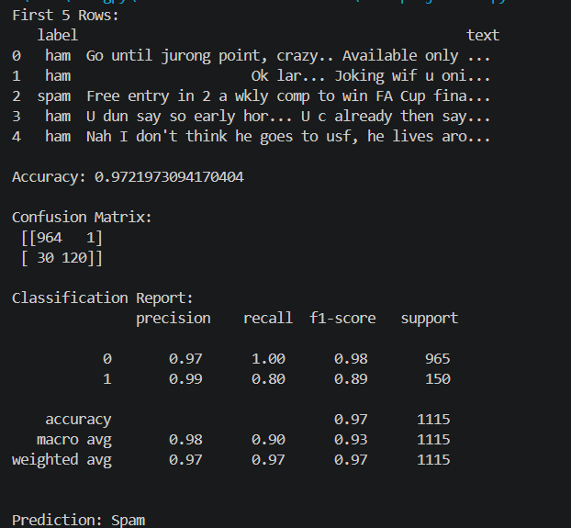
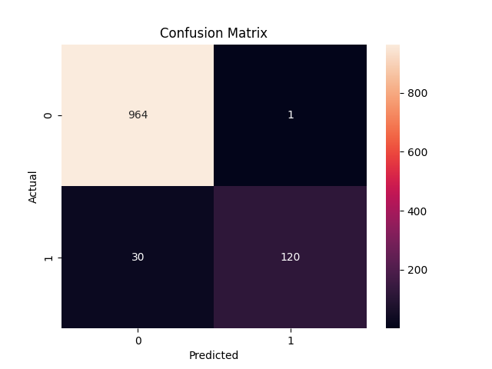
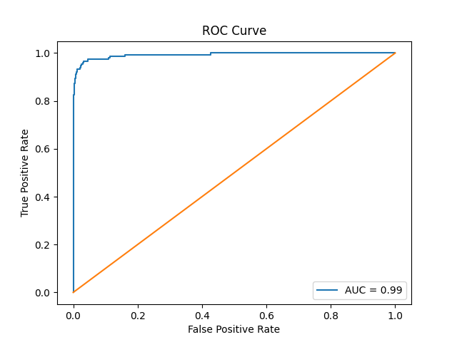
◆ Output Explanation
- Model classifies emails correctly
- Accuracy shows correctness
- Confusion matrix shows prediction results
◆ Performance Metrics
- Accuracy
- Precision
- Recall
- F1 Score
RESULTS AND FUTURE ENHANCEMENT
◆ Results
- Achieved high accuracy (~85–95%)
- SVM performs well for text classification
- TF-IDF improves feature extraction
◆ Comparison
Algorithm | Accuracy | Complexity
SVM | High | High
Naive Bayes | Medium | Low
Logistic Regression | Medium | Low

Git Hub Link of the project along with the report | https://github.com/Buvaneshvaran-R/ML-Mini-Project.git
REFERENCES
- Kaggle Spam Dataset
- Scikit-learn Documentation
- Hands-On Machine Learning Book
- UCI ML Repository
- NLP Tutorials

